Create table facebook

hive> CREATE TABLE facebook (userid int ,age int,dob_day int, dob_year int,dob_month int, gender string, tenure int,friend_count int , frie

ndships_initiated int , likes int , likes_received int , mobile_likes int , mobile_likes_received int , www_likes int , www_likes_received

int) ROW FORMAT DELIMITED FIELDS TERMINATED BY ',' TBLPROPERTIES ("skip.header.line.count"="1");

OK

Time taken: 0.485 seconds

hive>

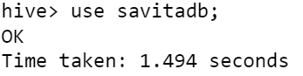



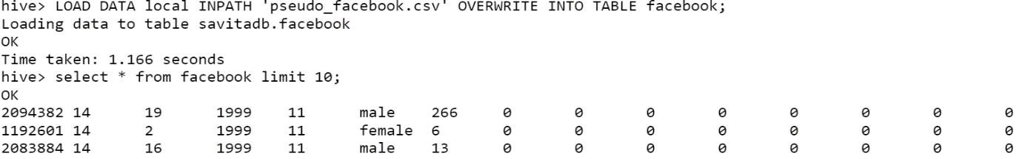

Q1: Find out the total no of users in the dataset

hive> select count(*) from facebook;

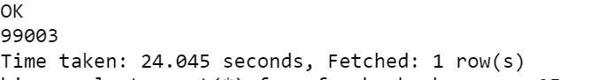

Q2: Find out the no of users above the age of 25

hive> select count(*) from facebook where age>25;

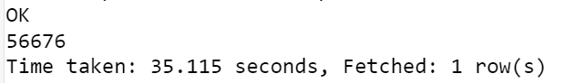

Q3: Do male face book users tend to have more friends or female users

hive> select sum(friend_count) from facebook where gender='male' and friend_count>0;

hive> select sum(friend_count) from facebook where gender='female' and friend_count>0;

Q4: How many likes do young people receive on facebook as opposed to old people

1. I Choice young people - minors age<19

hive> select sum(likes_received) from facebook where age<19;

1. I Choice old people - adults age>18

hive> select sum(likes_received) from facebook where age>18;

Q5: Find out the count of facebook users for each birthday month

hive> select dob_month, count(*) from facebook group by dob_month;

Q6: Do young members use mobile phones or computers for facebook browsing

hive> with q1 as (select sum(mobile_likes + mobile_likes_received) s1 from facebook where age<19), q2 as (select sum(www_likes + www_likes_

received) s2 from facebook where age<19) select case when q1.s1 > q2.s2 then 'Mobile' when q1.s1<q2.s2 then 'Web' else '' end as result from q1,q2;

hive> with q1 as (select sum(mobile_likes + mobile_likes_received) from facebook where age<19) , q2 as (select sum(www_likes + www_likes_re

ceived) from facebook where age<19) select * from q1,q2;

young members

q1 for Mobile_likes so mobile user= 4704827

q2 for www_likes so browser user= 2800190

Q7: Do adult members use mobile phones or computers for facebook browsing

hive> with q1 as (select sum(mobile_likes + mobile_likes_received) s1 from facebook where age>18) , q2 as (select sum(www_likes + www_likes

_received) s2 from facebook where age>18) select case when q1.s1 > q2.s2 then 'Mobile' when q1.s1<q2.s2 then 'Web' else '' end as result f

rom q1,q2;

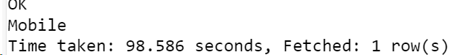

hive> with q1 as (select sum(mobile_likes + mobile_likes_received) from facebook where age>18) , q2 as (select sum(www_likes + www_likes_re

ceived) from facebook where age>18) select * from q1,q2;

adult members

q1 for Mobile_likes so mobile user= 14129186

q2 for www_likes so browser user= 7944730